UHF high temperature resistant metal tag

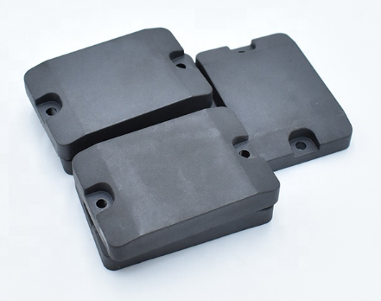
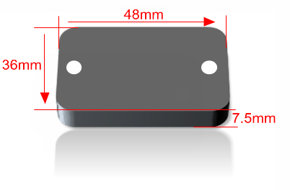

Technical Characteristics:

Model | ST-H101
compliance | EPC Class1 Gen2, ISO18000-6C
Frequency | CN&US (902-928)Mhz ;
Chip | Alien-Higg3/IPJ-M4QT/ NXP chips
Memory | 96(128)-bit EPC ; 512-bit user memory; 64-bit TID
Write times | 100,000 times
Read/Write | Yes
Data Storage | 50 years
Fixed reader [PERP=2W] | ≧8.0M
Handheld reader  [PERP=0.8≈1W] | ≧4.0M
Application | Metal surface

Physical parameter：
：

Dimension | L:48*W:36*T:7.5mm
Material | Special engineering materials
Color | Black, write
Installation Method | Lock screw, glue, bind
Weight | 12.05g
IP | IP68 Standard: GB/4208
Storage temperature | -60°С～150°С
Work temperature | -60°С～230°С
Material property | Wear-resistant, strong acid and alkali-resistant, corrosion-resistant

Performance curve test chart：
：

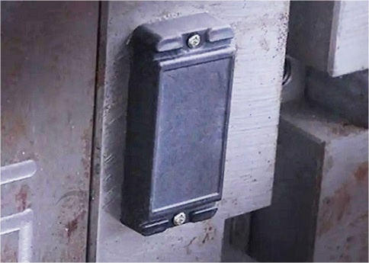
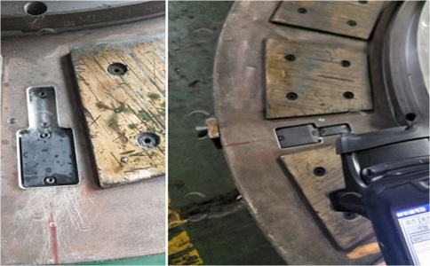
Application:

